EL4012 Lab 2: Linux Networks

Learning Outcomes

1. Configure Network Access for Virtual Machine
2. Run basic network commands to explore network configuration

In this lab we cover the setup which we will use in all future work.

  
In the lecture we have looked at the datalink layer. We can use the Linux networking commands to explore the network and configure our network adaptor.

1. Start your virtual machine and run settings - click the loudspeaker top right of the window, then the ‘Wired Connected>Wired Settings’ entry (this may appear differently depending on set-up). You should then see a summary of your Wired data-rate:

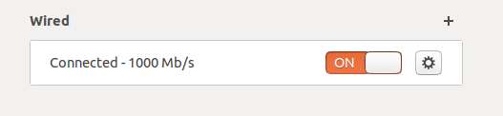  
  
To begin with, it appears as if you are using a ‘wired’ network – this is because your ‘Virtual Machine is connected to your ‘Real Machine’ internally via a simulated wired connection.



Click on the button, and write down the value of the following items as displayed:  
  
Link speed:  
  
IPv4 Address:  
  
Hardware Address:  
  
Don’t change any settings. You may recall that the MAC address is sometimes referred to as ‘Physical Address’ or ‘Hardware Address’ – it will appear as a 12-character hexadecimal address, as discussed in the lecture.

1. Close all the settings windows. Think carefully about the information you have written down – is it a ‘real’ network card, or a ‘virtual’ one? . . . . Actually, it is a ‘virtual’ one, but it is connected to a ‘real’ network card which sits on a real network. VMware presents us with an imaginary network which we can use – data then gets sent to the underlying network (subject to any security restrictions).
2. We need to set up the networking so that your Virtual Machine directly accesses the real network that your real network card (wired or WiFi) is connected so, so that we can access other real devices later.  
     
   This is potentially problematic because instead of you all working on the same hardware on the same lab network here at UCLan, you will all be connected to your own networks using your own hardware.  
     
   The first thing to do is to find the addressing used on the (real) underlying network. Go to Windows, and in the ‘Type here to search’ box (bottom left) type: CMD  
     
   This should bring up a black windows with white text – the Windows command prompt. Type: ipconfig /all  
     
   This will bring up a list of several network adaptors, some real, some virtual (belonging to VMWare). Only ONE of them will have a ‘Default Gateway’ entry, like the one below. This is the real network:  
     
   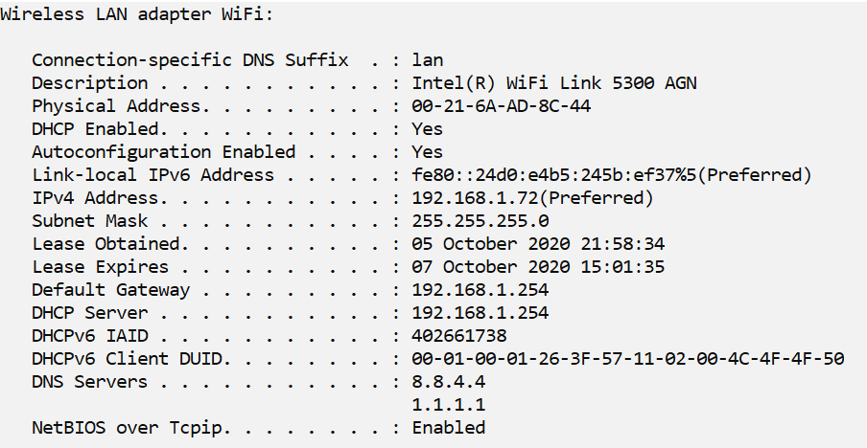

The important part of the address shown in the red box is the first three decimal numbers, in my case 192.168.1 Many of you will have the same set, some may have ones beginning with 10.0 or 172.16 (read <https://en.wikipedia.org/wiki/Private_network> for more information). Write down those digits here:

­­­­­­­­­­­­­­­­­­­­­­__________________________________

We *may* also need the name of the active network card – the one in the ‘Description’ field. Mine is shown as Intel® WiFi Link 5300 AGN

Write yours down here:

______________________________________________

We need to get access to that network and card from our Virtual Machine.

1. Now to configure our Virtual Machine Networking. If those first three numbers are the same as the ones you noted for the start of the IPv4 address in part 1, you are done and can move on to section 5. If they are different then we need to do some configuration.  
     
   The network card is configured by going to the top left hand corner of your Ubuntu window and selecting Player>Manage>Virtual Machine settings. You will see a window like the one below. Select Network Adaptor as shown and make the configuration selections the same:

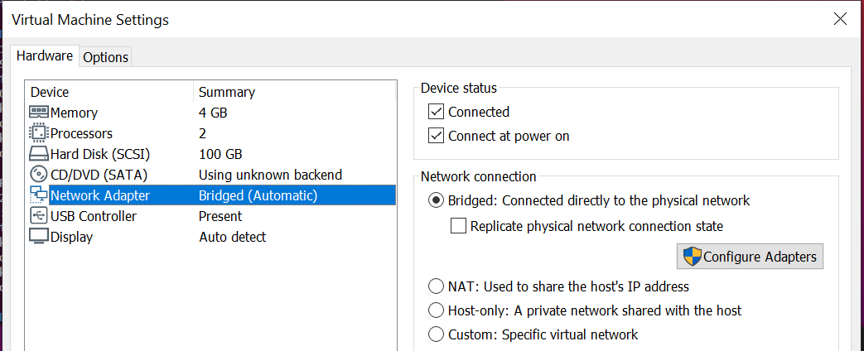

In the main window above, select Bridged, Replicate and in ‘Configure Adapters’ select only the one you identified in part 3.

Click OK twice to close down the configuration windows. Next time you start up the machine this change will take effect

Click the Power Off button  next to the loudspeaker you clicked earlier and then once again when the window opens. Select restart. This should implement the new settings.

1. Check that your address is on the right network. Repeat section 1 and check that the address starts with the digits you identified above in section 3 (192.168.1 in my case). This means that your virtual Ubuntu machine is on the same network as your real Windows machine.
2. You can check the network using the command line. At the prompt, type:

ifconfig

Depending on if you have needed it before, it will probably not be installed. Follow the instructions that are on-screen to install it (you may need your password since you will need ‘sudo’ privileges).

There will most likely be an ‘ens33’ entry in the list that is printed – this is your network card. Check that the ‘inet’ address is the same as that in section 5 above. Note that this also provides your MAC address, although it labels it ‘ether’ (you will probably know why).

1. You can now start to explore the network you are on. One way of doing this is to find out which other machines are connected – this can be done with the ‘nmap’ command.  
     
   You will need to install the ‘nmap’ utility using one of the application installation methods available in Ubuntu – the ‘advanced package tool’. Open a Terminal window and type:  
     
   sudo apt install nmap  
     
   and when prompted enter ‘y’ to install new packages. Watch the endless stream of incomprehensible Linux gibberish until the prompt is restored.  
     
   Enter the following nmap command to list out all the machines connected to the network (substitute your numbers for those in red):  
     
   nmap -sP 192.168.1.0/24 //I’ll explain the numbers next week  
     
   Wait until it completes. It takes a while because it tries every address in the range you have given, and waits for the reply to see if there is anyone home. You should be able to spot your own IP address (see section 6 above).

You should get a list of device addresses with enough additional information to identify them as devices connected to your network, e.g. mobile phone. One of these devices will be the (default) gateway, with the address we determined earlier. Mine looked like this:

ifconfig  
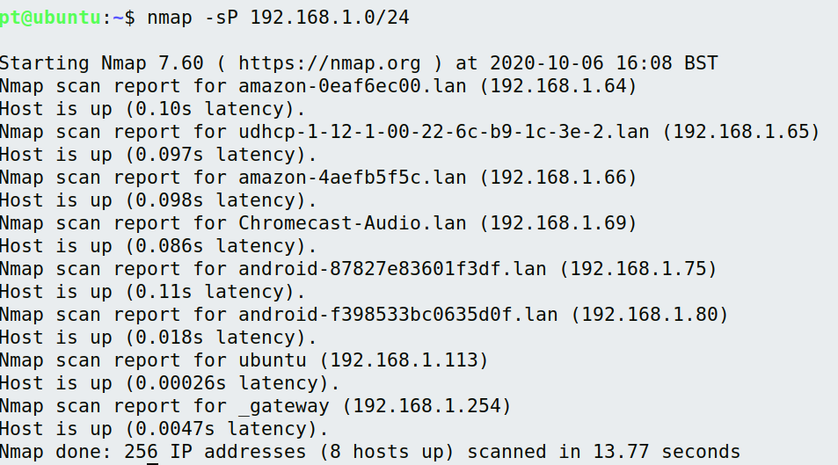

The last two addresses above are the gateway and the Ubuntu virtual machine. Note that on my network, all addresses start 192.168.1.

**Summary**  
  
A lot of work just to get the machine how we want it. It is important to get this right as we will need it for future work when we add other devices to the network. Next week we will do more work on IP addresses.